PROJECT 1 – THREAT MODEL THE AI IDENTITY SYSTEM

Introduction:
This project focuses on security threat modeling for an AI-based identity security system. The system includes user authentication, an AI agent, internal APIs, an LLM, and a RAG knowledge base. Since these components handle authentication information and sensitive data, they may be exposed to different security attacks.
The project studies the system flow and identifies possible threats that could affect different components. It focuses on attacks such as identity token theft, authentication tampering, LLM API key exposure, agent identity spoofing, and RAG knowledge-base poisoning.
The identified threats are further analyzed using attack trees and the STRIDE model. A risk register is used to evaluate the likelihood and impact of each threat and to assign suitable security controls. The threats are also mapped to MITRE ATLAS techniques to understand the related AI attack methods.
The overall aim is to understand the possible security weaknesses in the system and provide a clear approach for identifying, analyzing, prioritizing, and controlling security risks.

Step 1 – Secure Nova AI Identity Data Flow
Description:
The data flow represents the main components of the Secure Nova AI Identity Security system and how they communicate with each other. A human user sends a request through the identity provider, which connects to the application and AI agent. The AI agent communicates with the internal APIs, LLM, and RAG knowledge base. The arrows represent the flow of requests and responses between these components.
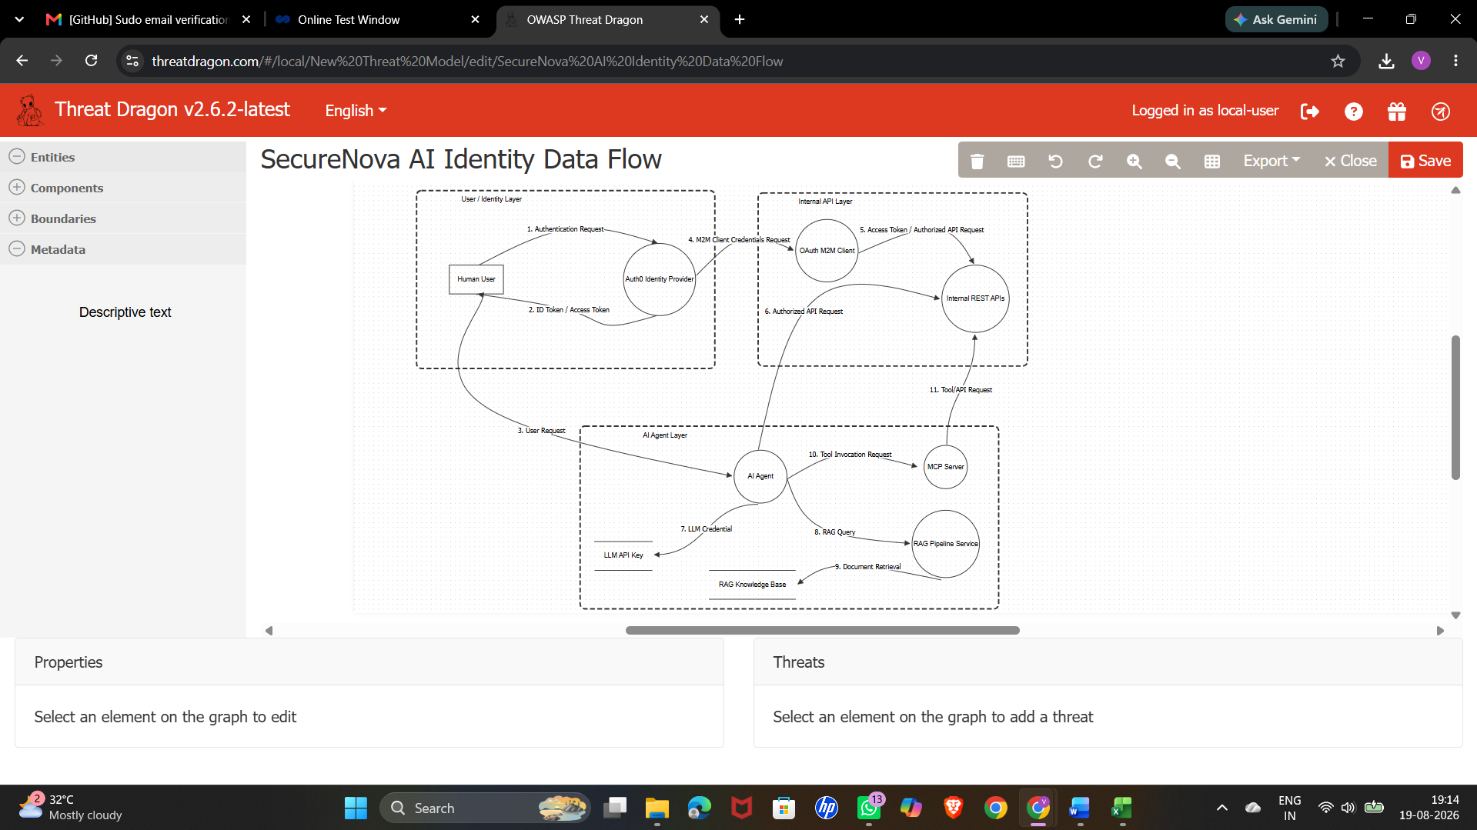

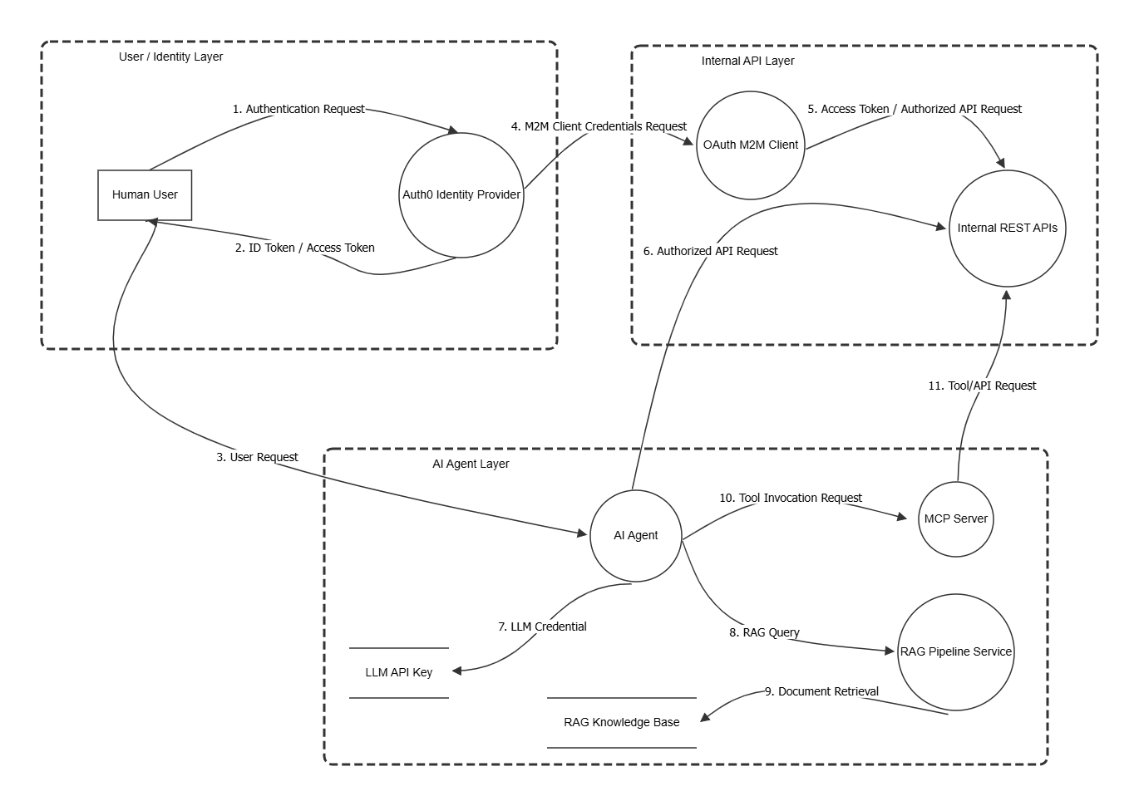

Step 2 – Authentication Threats
Description:
The Auth0 identity provider is selected, and the related security threats are identified. The threats include identity token theft, authentication request tampering, and authentication information disclosure. These threats represent possible security risks in the authentication process.
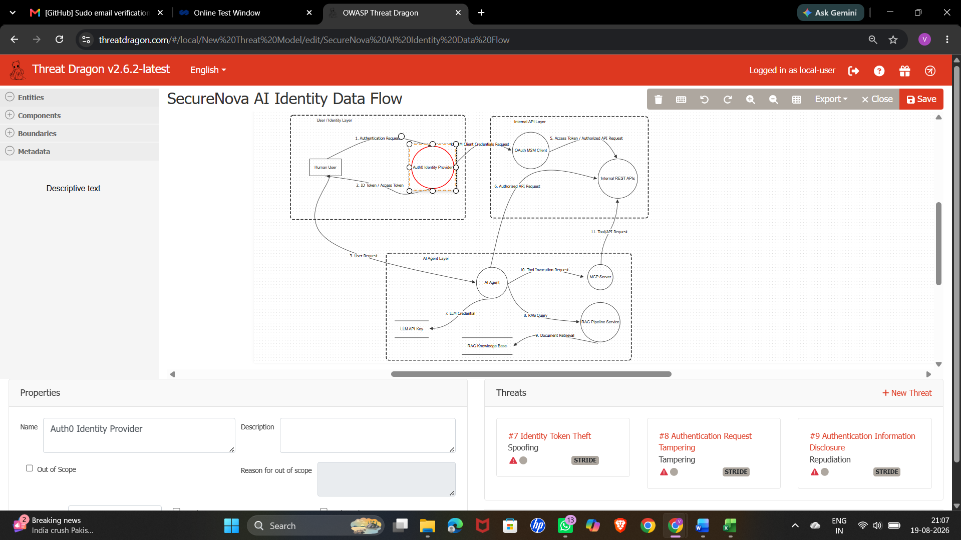
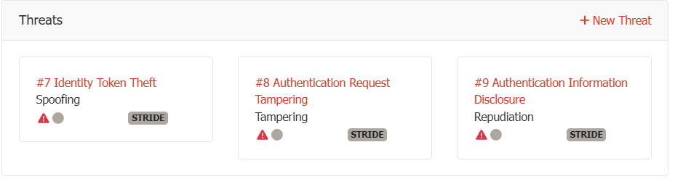
Step 3 – LLM API Key Exfiltration Attack Tree
Description:
The attack tree explains different ways an attacker could obtain the LLM API key through prompt injection. The possible paths include malicious user prompts, indirect prompt injection, and poisoned RAG content. These attacks may cause sensitive information to be revealed and could lead to API key exposure.
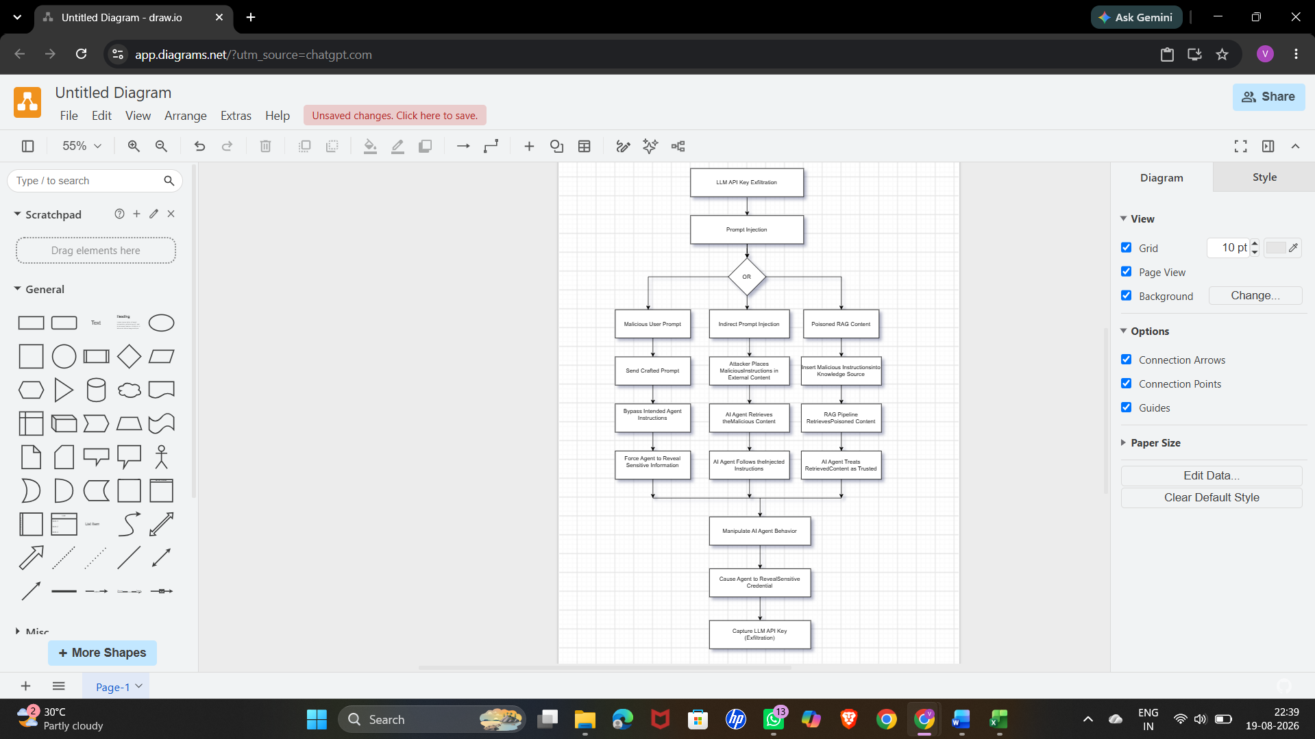

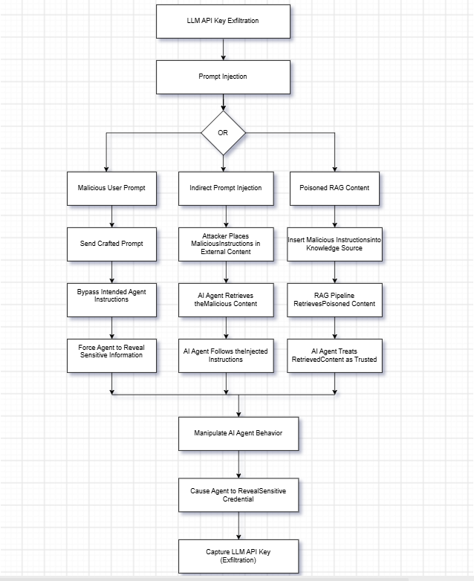

Step 4 – Agent Identity Spoofing Attack Tree
Description:
The attack tree explains different ways an attacker could pretend to be a trusted AI agent. Possible methods include stealing agent credentials, modifying or forging an identity token, and replaying a valid token. Successful exploitation may provide access to protected internal APIs with higher privileges.

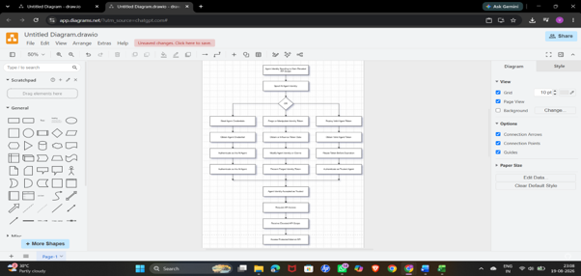

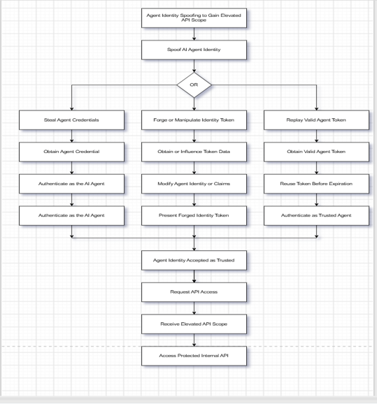
Step 5 – RAG Chunk Poisoning Attack Tree
Description:
The attack tree explains how an attacker could add, modify, or insert misleading information into the RAG knowledge base. The poisoned information can later be retrieved by the RAG pipeline and processed by the AI agent. This may cause the AI agent to generate an incorrect or attacker-influenced response.

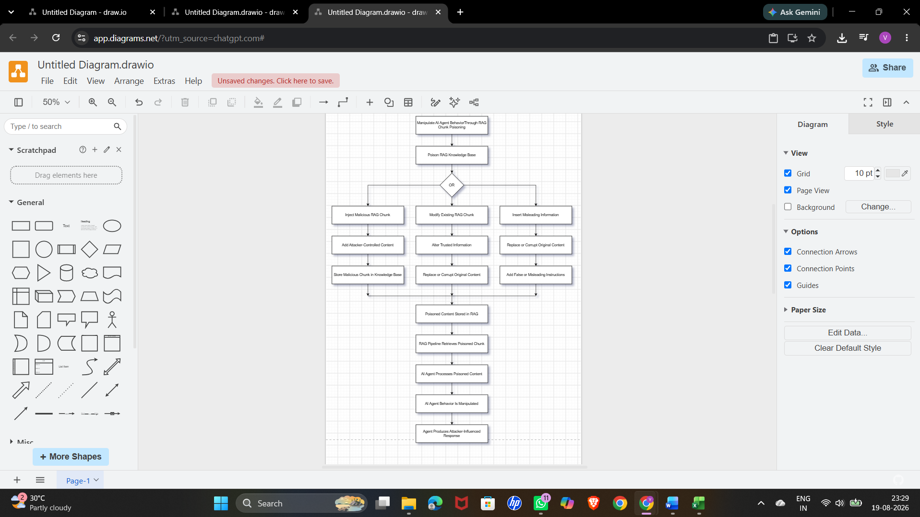
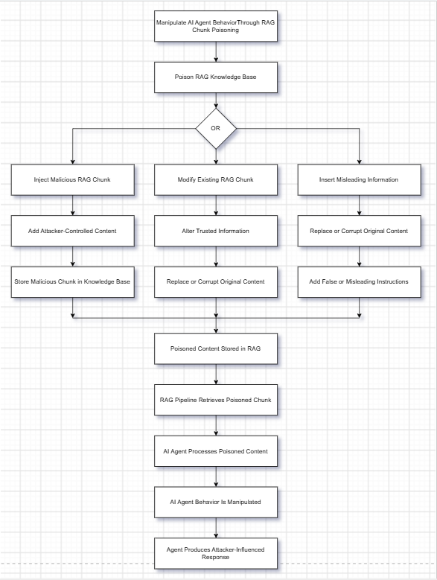

Step 6 – STRIDE Threat Matrix
Description:
The threat matrix organizes the identified security threats using the six STRIDE categories: Spoofing, Tampering, Repudiation, Information Disclosure, Denial of Service, and Elevation of Privilege. The system components are matched with the possible threats that may affect them.
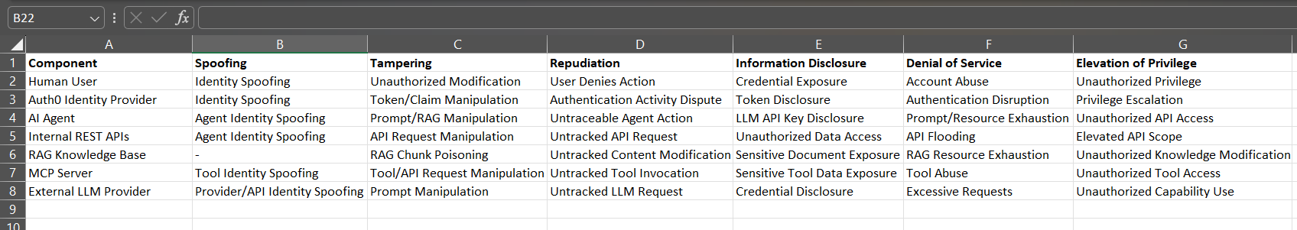


Step 7 – Risk Register
Description:
The risk register contains the identified security threats along with their likelihood, impact, risk score, and priority. It also includes the responsible owner and the security control planned for each risk. This helps in identifying the risks that require higher attention.


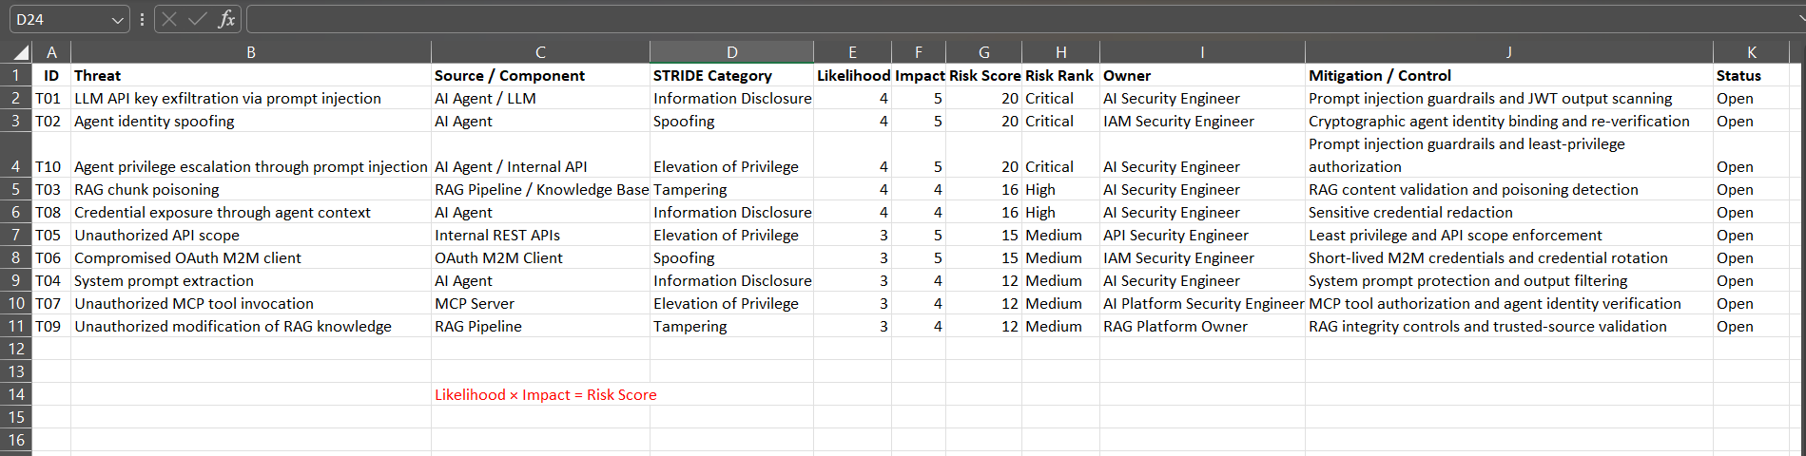

Step 8 – MITRE ATLAS Threat Mapping
Description:
The identified security threats are mapped to related MITRE ATLAS techniques. The mapping connects each threat with a relevant AI attack technique and provides information about how the technique relates to the identified risk. This helps in understanding the threats using recognized AI security techniques.
